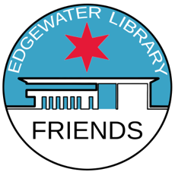
Friends of the Edgewater Library
Membership Application

Who We Are
Friends of the Edgewater Library, an Illinois 501(c)(3) non-profit organization, is an all-volunteer group supporting the Edgewater Branch and the community. Annual dues, plus donations, enable us to fulfill our mission: to partner with and advocate for the Edgewater Branch Library, respond to our community’s library needs, and educate and engage the community in using and enjoying all our library’s resources.

Our membership year is June 1-May 31. We invite you to attend meetings on the fourth Saturday of most months. We offer opportunities to share your skills, grow your social and professional network, add value to our community and be a part of something that enriches our neighborhood and ourselves.

What We Do
Some of the Friends of the Edgewater Library activities include the following.
- Funded the Early Learners’ Literacy Nest for children up to age 5.
- Furnished the Teen Lounge/YOUmedia maker area, a digital learning space.
- Sponsor and organize programs, activities, and other events at the library for the community.
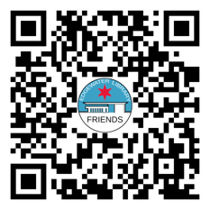
- Purchase books, DVDs, and other materials for the library.
- Support the Summer Reading Program for children.
- Raise funds through our used book sales to support the library.
Become a Member Today!
Use your cell phone camera to scan the QR code or go to www.foelchicago.org to join and pay with PayPal or a credit card. Or, mail a check or money order with the completed form to the address below. If you have questions, please email info@foelchicago.org. Please join us and find a world of Friends!
- - - - - - - - - - - - - - - - - - - - - - - - - - - - - - - - - - - -Clip Here- - - - - - - - - - - - - - - - - - - - - - - - - - - - - - - - -- - - - - - -

Full Name: _______________________________________ Email: ______________________________
(please print) (required)
Address: _________________________________________ Mobile #: __________________________

Select your level of membership:  ☐ Friend - $10  ☐ Very Good Friend - $20  ☐ Best Friend - $50  ☐ Friendly Benefactor - $100  ☐ Very Friendly Benefactor - $200  ☐ Best Friend Benefactor - $500 | Payment options:  Make payable to Friends of the Edgewater Library  ☐ Check  ☐ Money Order
Return to: Friends of the Edgewater Library, c/o Edgewater Library, 6000 N. Broadway, Chicago, IL, 60660.

