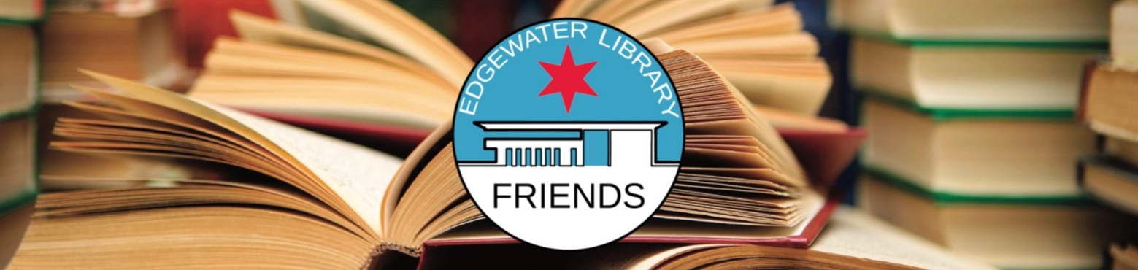

Cakes and Cozy Mysteries: A Sweet Combination
Friends of the Edgewater Library prepared this list of just some of the resources available through the Chicago Public Library (chipublib.org). The Edgewater Branch of the Chicago Public Library is located at 6000 N. Broadway.
Austrian Desserts: Over 400 Cakes, Pastries, Strudels, Tortes and Candies by Toni Mörwald and Christoph Wagner – Easy-to-understand instructions on how to make Old World dishes such as Linzertorte and Apfelstrudel as well as contemporary and diet-conscious recipes.
Cook’s Illustrated Baking Book: Baking Demystified With 450 Foolproof Recipes from America’s Most Trusted Magazine (available at Edgewater Library) – Includes recipes for bread and pizza in addition to desserts and other sweets, perfected through trial-and-error sessions in America’s Test Kitchen.
Extraordinary Cakes: Recipes for Bold and Sophisticated Desserts by Karen Krasne (available at Edgewater Library) – Dubbed the “Queen of Cakes” by Gourmet magazine, Krasne shows home bakers how to create showstoppers that are as delicious as they are beautiful.
Piece of Cake: Home Baking Made Simple by David Lesniak (available at Edgewater Library) – Recipes for 120 American classic cookies, cakes, muffins, and brownies.
Sweet Enough by Alison Roman (available at Edgewater Library) – Written for those who think they don’t have the time or skill to create a dessert.
Enjoy a taste of these cozy mysteries (a sub-genre of crime fiction but with a lighter tone):
The Goldy Bear Culinary Mystery Series by Diane Mott Davidson includes The Cereal Murders; Chopping Spree; Dark Tort; Killer Pancake; Sticks and Scones; and Sweet Revenge. Many are available in hard cover, paperback, audiobook and/or ebook format.
The Hannah Swenson series set in Minnesota by Joanne Fluke includes Pink Lemonade Cake Murder; Christmas Cupcake Murder; and Apple Turnover Murder. All have food and drink recipes sprinkled throughout and most are available at the Edgewater Library.

The mission of Friends of the Edgewater Library is to partner with and advocate for the Edgewater Branch Library, respond to our community’s library needs, and educate and engage the community in using and enjoying all our library’s resources.

Friends of the Edgewater Library | 6000 N. Broadway, Chicago, IL 60660 | info@foelchicago.org | foelchicago.org

