o
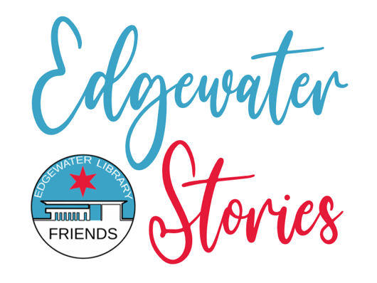

Frequently Asked Questions

What is Edgewater Stories?
Edgewater Stories is an initiative created by Friends of the Edgewater Library to reach out to community organizations and individuals to hear their stories about how and why they came to Edgewater. We’ll potentially share the written stories in person in a program at the library in September and post them on our website, foelchicago.org.

What is Friends of the Edgewater Library?
Friends is a non-profit volunteer organization that supports the Edgewater Branch of the Chicago Public Library. It raises funds to supplement the library’s budget to provide programs for the community. The group also purchases equipment, books, and supplies for children, teens, and adult activities.

Why is Friends of the Edgewater Library collecting stories from the community?
We want to learn about and become more aware of the diverse cultures in our neighborhood, and we feel the community might be interested in this, too. Everyone has a story to tell and sharing it will help people find common ground with neighbors.

What should I include in my story?
We’re asking individuals to write their stories about how and why they came to Edgewater. The stories are whatever individuals want to share. It may include where and why the journey to Edgewater began. (e.g., Was it to move to Chicago for a job, to start a business, or to be near family? Was it to immigrate to the United States?)

Your story may also include the challenges faced and overcome (e.g., learning English, finding a job). What has the “Edgewater experience” been like? If you are a library patron, a business owner, work in Edgewater, or are a client or member of a community organization, please mention that connection and anything you feel is relevant to your story. Do not include your home address or other personal identifiers in your story.

Who is Friends of the Edgewater Library asking to participate?
Community organizations and their clients and members, business owners, members of faith-based organizations, and Edgewater residents in general. We encourage all ages to participate.

When is the deadline?
July 1 for our September 2024 program. However, we will accept them anytime for potential future programs, and to add to our website.

What is the maximum length and format?
1-3 typed pages.

How should I submit my story, and what is the deadline?
Submit it as a Word document in English, single-space with no indentation. Use Arial or Calibri 11 pt. font. Please title your story, for example, “My Story” by (your name), or provide another suitable title.

Please email your story with contact information (name, email, mobile phone number) to info@foelchicago.org by June 1, 2024. In the subject line, put “Edgewater Stories submission.” You may also include up to three photos.

What if I need help writing or translating the story into English?
Email info@foelchicago.org with your request, and we’ll try to accommodate you.
You also may submit your story in English and another language.

What will happen to the stories?
By submitting your story and photos, you give Friends of the Edgewater Library permission to print and post them on its website, foelchicago.org, and on our social media pages, Facebook and Instagram. We may edit the stories for length and clarity. We reserve the right to decline an article that we determine is inappropriate for our use.

Friends of the Edgewater Library will invite some individuals to read their stories (or have them read) at a program at the Edgewater Branch Library, 6000 N. Broadway, on September 14. We anticipate contacting those individuals by mid-August. We may hold some stories to be read at another program.

Do I need to include my name on the story?
We will need your name and contact information so we may reach out to you if your story is selected. However, you may choose not to have your name printed or read with the story; instead, we’ll identify the story as written by “anonymous.” You may also decide to use your first name and last initial as the author.

Do I have to read my story at a program at the library?
No, you may choose not to read it. You may also ask Friends of the Edgewater Library or someone else to read it for you.

Will I be compensated for my story?
No. This is a community project of Friends of the Edgewater Library, and your story submission is voluntary.

What if I have other questions?
Email info@foelchicago.org. Please put “Edgewater Stories inquiry” in the subject line.

