Friends of the Edgewater Library
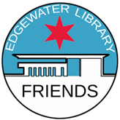
Fact Sheet
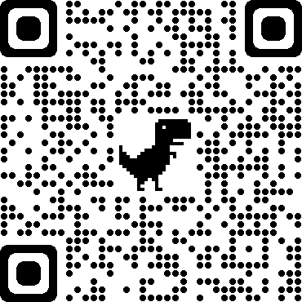

Background
Friends of the Edgewater Library was incorporated on May 6, 1990, as a 501(c)(3) nonprofit organization. Friends of the Edgewater Library is led by a volunteer Board of Directors and several committees.

Mission
We support the Chicago Public Library’s mission and its objectives to engage, strengthen and encourage a more inclusive and connected community. Our mission is to partner with and advocate for the Edgewater Branch Library, respond to our community’s library needs, and educate and engage the community in using
and enjoying all our library’s resources.

Our support
We work with Branch leadership and staff to provide resources to support the library and engage
our community. For example, the Friends’ group provides funds for supplies, equipment, and programs. Our primary source of revenue is from book sales, which are on hold since 2020.

We bought AV equipment and furniture and funded honorariums to presenters for programs arranged by the library and Friends of the Edgewater Library. In April 2020, we purchased a Zoom subscription and have shared it with library staff since then. We also purchased face masks for staff when the library reopened that year.

Our programs
Friends of the Edgewater Library initiate and facilitate programs that promote reading and encourage a lifelong curiosity for knowledge. Some programs center on books and authors, Chicago literary figures, historical or literary events, and anniversaries.

Historical portrayals have included Rachel Carson, Louisa May Alcott, and Florence Nightingale. In 2020, we commemorated the 100th anniversary of the 19th Amendment with actors playing the roles of Illinois suffragettes. We’ve offered presentations about Nelson Algren and Herman Melville and held conversations with authors Mikki Kendall, Nina Barrett, Elliott Gorn, Cyndee Schaffer and Jill Wine-Banks. Recent programs included “The Mystery of Nancy Drew: Celebrating 90 Years,” “Writers on the Edge/Flash Fiction,” and Redeeming Justice: An Inside Look at Wrongful Conviction.”

We also talk about books. The No Book Club (individuals informally discuss what they’re reading) began in August 2016 and is our longest-running program.

For more information
website foelchicago.org
email info@foelchicago.org
address Friends of the Edgewater Library, c/o Edgewater Branch, 6000 N. Broadway, Chicago, IL 60660

