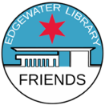

Edgewater Branch Library
Free resources, programs, and activities

Friends of the Edgewater Library prepared this list of just some free resources available at the Edgewater Branch of the Chicago Public Library. Our mission is to partner with and advocate for the Edgewater Branch Library, respond to our community’s library needs, and educate and engage the community in using and enjoying all our library’s resources. Find us at www.foelchicago.org.

- Books (including large print and in various languages), magazines, newspapers, CDs, and DVDs.

- Computers with Microsoft Office, design software for photo editing, AV creation and editing.

- Internet – (databases and apps) including record search on Ancestry.com, and access to eBooks, audiobooks, digital comics, movies, music and magazines from Hoopla, OverDrive, and Flipster.

- Printers (10 copies free each day), scanner and Wi-Fi service.

- Study Rooms –space for four people. Meeting Rooms – seating for 80 people.

- CyberNavigator – help in computer basics, creating documents and sending email. Make an appt.

- Private counseling with a mental health clinician on Tuesdays. Call (312) 745-0625 for an appt.

- Activities for children and teens include the Early Learners’ Literacy Nest (up to age 5), storytelling, science and craft activities, board games and a book club. In the Youmedia Center, high schoolers may borrow laptops, play video games and use other media.
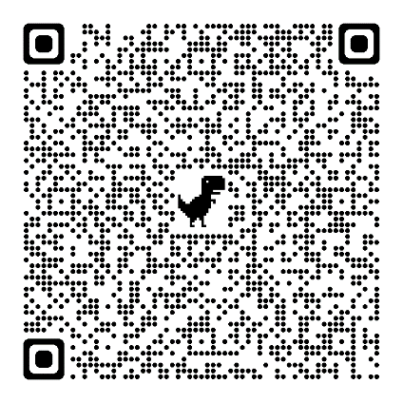
- Programs and activities - Visit the library’s events page here:

6000 N. Broadway | (312) 742-1945 | edgewater@chipublib.org | www.chipublib.org/locations/28
Open Mon. & Wed. 10 a.m.-6 p.m. |Tues. & Thurs. 12-8 p.m.| Fri. & Sat 9 a.m.–5 p.m. | Sun. 1-5 p.m.

